Type-C To Dual Personality USB 3-in-1 Card Reader
Pen-Style Type-C Adapter featuring SDTM/TF Card Reader
with folding, dual personality USB/MicroUSB Interface

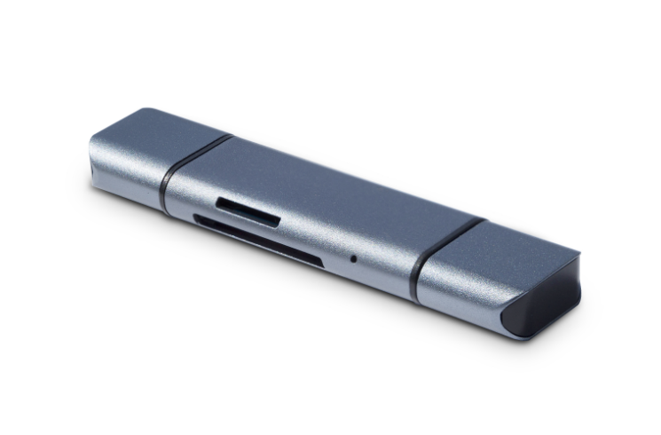

Descrption:
Innovative in design, featuring a dual personality full-size USB and MicroUSB plug which can be changed in a matter of seconds to suit your device's interface port. Also features a single Type-C on the other side for quick connection to Type-C devices, or for legacy USB or MicroUSB interface devices. The choice is yours.
Complete with a dual slot memory card reader for SDTM and TF type cards, housed in as stylish, pen-sized design which you can take anywhere.

Features:
- Multi-function three-in-one OTG reader is a multi-function card reader with three universal interfaces.
- Tested, Type-C interface is fully compatible with the latest Macbook, LTV, Xiaomi, Nokia, Huawei, Sony, Meizu and other Type-C interface phones and computers. The USB interface on the other end uses the latest two-in-one concept of Micro USB and USB 3.0, 2-in-1 interface.
- In addition to the USB3.0 interface for traditional computers, this interface can also be used for all micro USB ports, Android smartphones such as Samsung, Xiaomi, Huawei, Sony, Meizu and other mobile phones.
- The smart phone itself has a USB support for USB OTG or USB host functions. The device does not support devices without OTG function.

SPECIFICATIONS
- Material：Aluminium Alloy+ABS
- Size：79*20*11mm
- Support card type：TF/SD card reader,OTG
- Feature：
Compatible with Windows
Compatible with Type-c laptop
Compatible with smart phone through OTG
Support OTG with USB Micro Mobile Devices

Product Code:
- Part number: C-TC-CR
- Product net weight: 21g
- Product size: 79*20*11mm
- Barcode: 8400800036735

